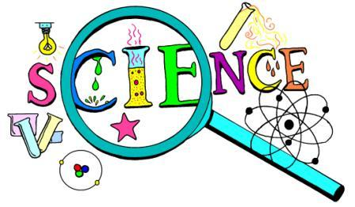
Encino Charter Elementary Science Fair 2014
Dear Parents,
Encino Charter Elementary School is having our annual Science Fair on May 8, 2014, from 5:30-7:00pm, before and during Open House. It will be located in the auditorium. We are looking forward to your child’s participation. Exposing elementary-age children to a variety of scientific experiences at home and at school, increases the likelihood that they will develop positive attitudes toward science. If your family has not explored science, now is a great time to create a meaningful science project. All students in fourth and fifth grades are required to complete a science fair project. This will go towards their overall science grade.
Project information must include the steps of the scientific method and must be posted on the display board that will be provided to each student by their teacher or your project will not be displayed. You must turn in an entry form in order to receive a science board. Please have your child return the completed entry form to their teacher by May 2, 2014. There is a project planning worksheet attached to help guide students through the scientific method. This year our school received display boards through a generous donation from the E-Team. Only one display board will be given per project. Participation ribbons will be given to all participants.
The project choices are numerous! For primary students, topics can be as simple as demonstrating the three states of matter, the push and pull of magnets, or the use of simple machines. For intermediate students, the projects can be more complex, depending on your child’s interests and ability. Projects may include experiments, demonstrations, research, collections and apparatus.
You need to be aware that your experiment will be handled and used by Science Fair visitors. Please provide clear directions for how to use your project. If your project contains a liquid or messy substance, please provide a roll of paper towels. A list of guidelines for a safe project is included with this packet of materials.

Thank you,
Mrs. Topalian
(Cut on dotted line, fill out entry form and turn bottom half into your teacher.)
---------------------------------------------------------------------------------------------------
2014 Science Fair Entry Form: (Due by May 02, 2014 to your teacher)

Student Name(s) ________________________________ Grade____________ Room #______

Project Description____________________________________________________________

_X______________________________________________
(Parent's/Guardian's Signature)
I have reviewed the Science Fair Guidelines with my child and will ensure that this project complies with them.

