Important! Guidelines for the Science Fair:
1. Must include the scientific method in your display.
2. You must use the display board given to you by your teacher or the project will NOT be displayed at the Science Fair!!
3. May not include inhumane treatment of people or animals.
4. No living organisms except plants may be exhibited at the fair.
5. Anything that is normally prohibited on school property or that could be harmful to the public cannot be exhibited at the fair. It includes, but is not limited to harmful chemicals, caustics, acids, poisons, explosives, open flames, combustible materials, and any sharp items (knives, pins, hypodermic needles).
6. There will be space for each exhibitor to have a display board and a small amount of table space in front of the display board. No running water or electricity will be available. If you are interested in developing a project involving electricity, you may choose to use batteries.
7. Projects should be developed, carried out, and exhibited by students with minimal help from adults.

Science Fair Display Board Ideas:
Use colors, make clear and neat pictures, and be creative! This is only one example of a project display board. There are many different ways to display information. The following resources are available to help your child plan and organize a project:
- Encino Elementary Library
- Local Library
- Encino’s web site for links to great projects
- Your teachers and science teacher(saratopalian6@gmail.com or room 24)
- Project planning worksheet
- Science Fair Idea List

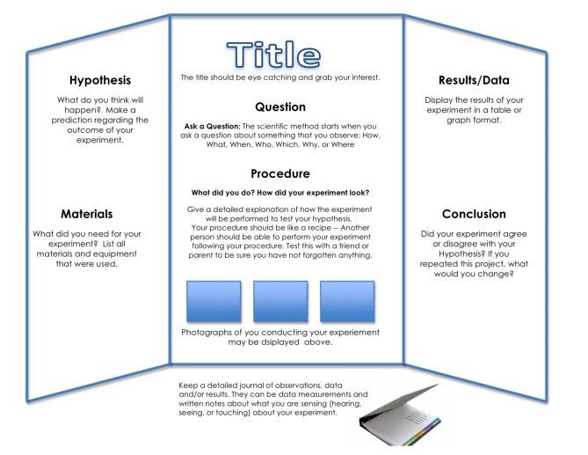
Project Checklist:
_Title
_Students Name
_Question
_Hypothesis
_Materials
_Procedure
_Record Results
_Conclusion

